**AUTOSAR studio**

**User manual**

Snapshots

Display all your own projects/systems you have created

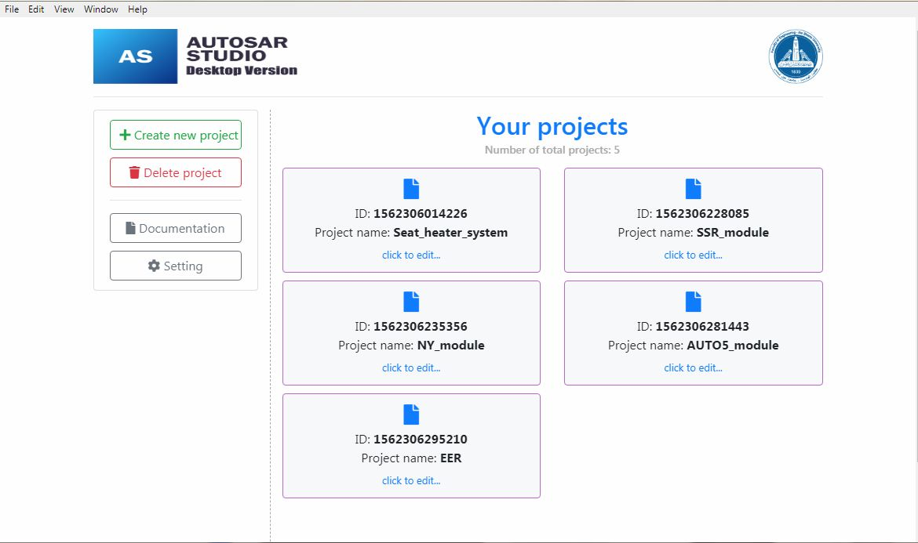

At click on create new project detect the project name and take care with it’s validations

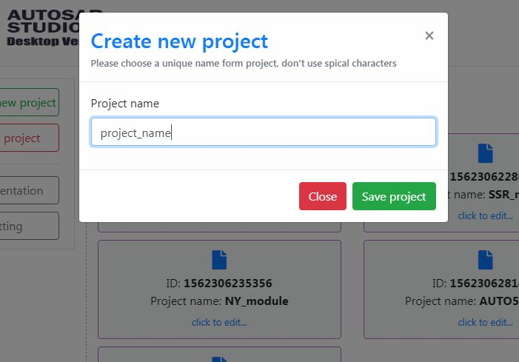

Also deleting of the project is very easy, just click on delete some project button then choose from select menu the project want to delete it.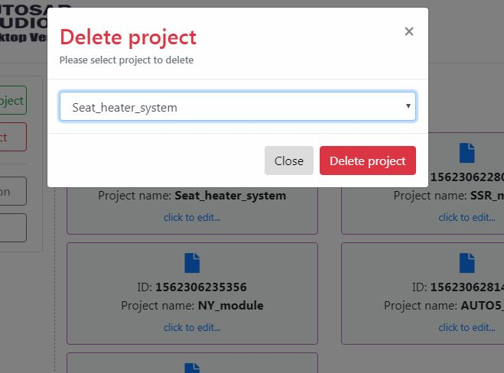

After create your project you can do more customize of it, like create SWC/detect your data types, etc…

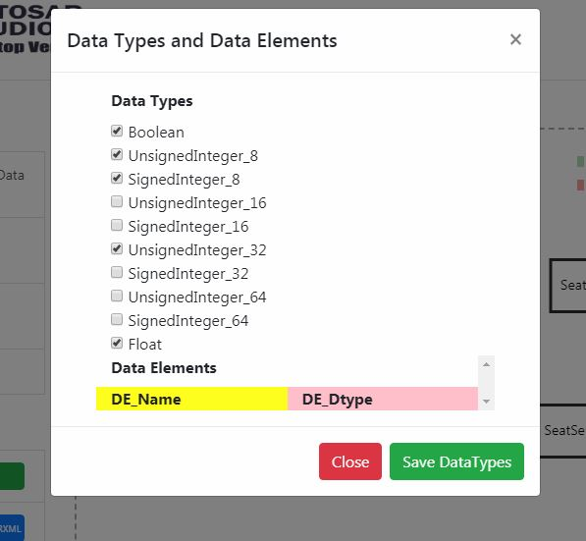

Then sure in first you need to create an interface then detect its type to be able to in next to create ports and linked it together

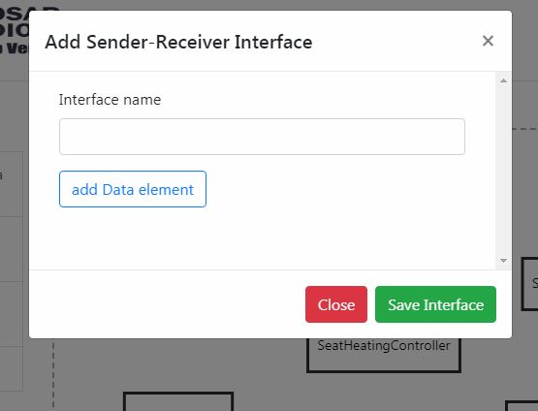

here you can select the sender-receiver name and linked it with data element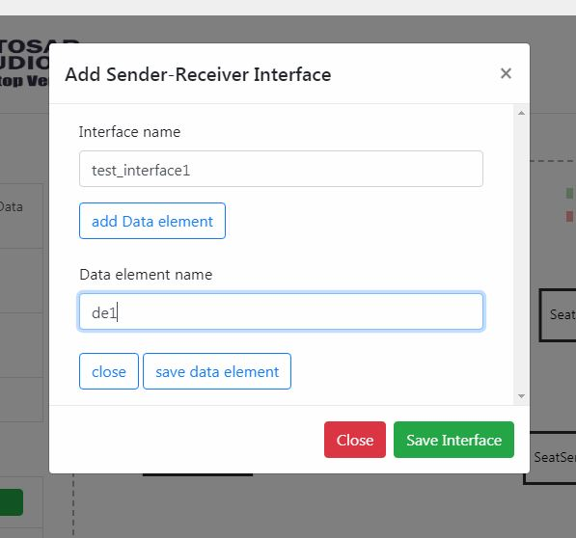

Link the interface whose created with it’s data element

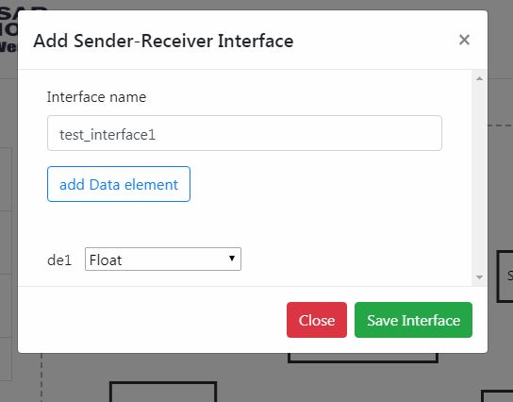

You can see, there is the new data elements was implemented with the data type section  
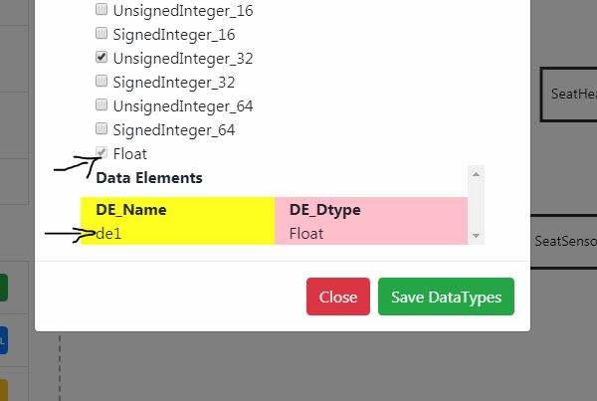

Also, adding client server interface type from left menu, the steps of adding interface it’s the same of add sender-reciver  
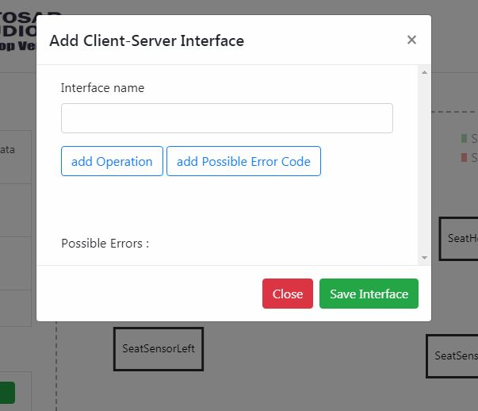

set name of created operation  
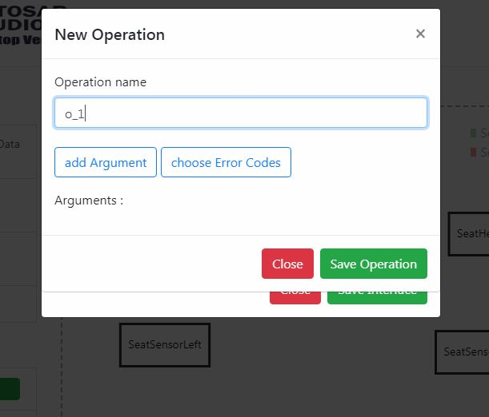

select the arguments of created operations  
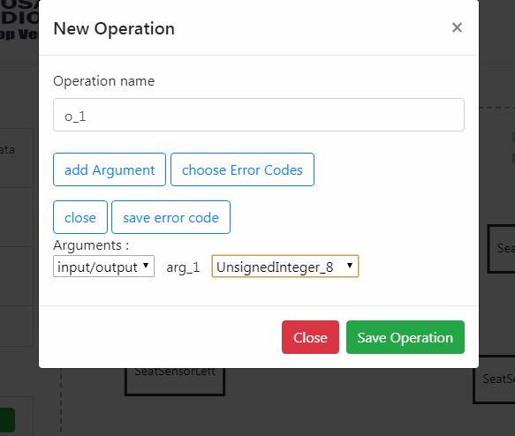

then you can see linked relation between added items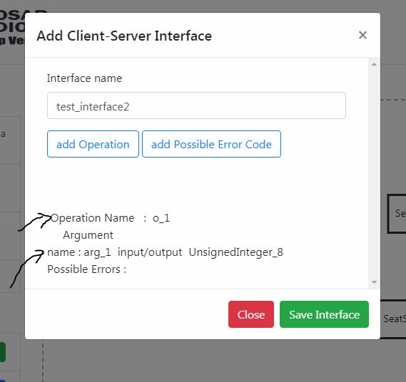

To show all relationships choose all interfaces from left menu  
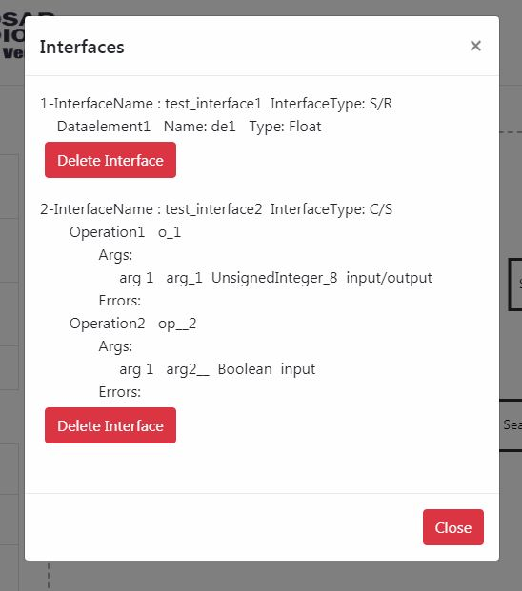

Build you SWC from builder window  
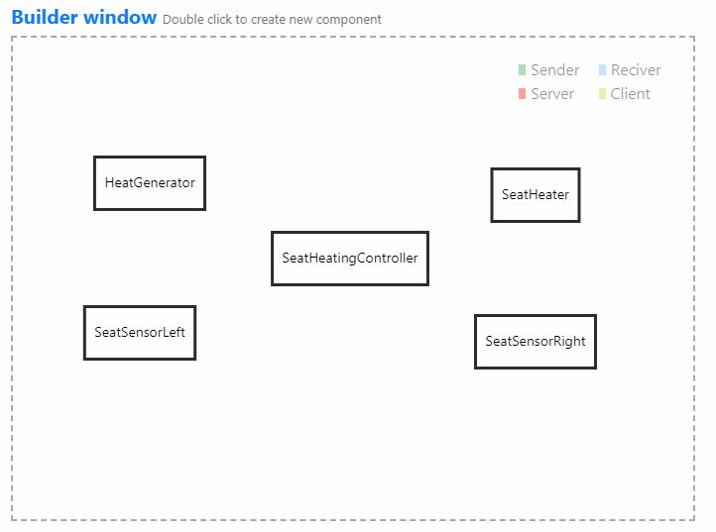  
  
To create new port make double click on any free space on builder window  
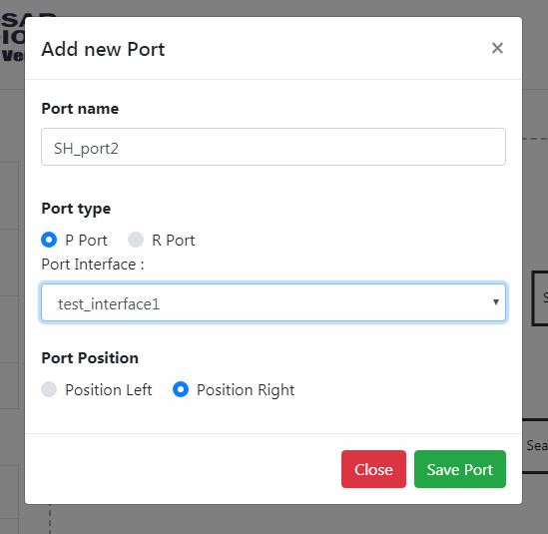  
after finishing from creating you can get look like this  
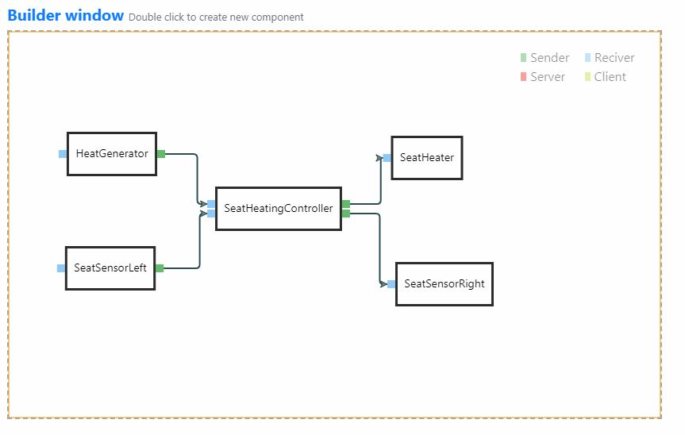

To more custmization on ports, make right click on detected port then choose properties   
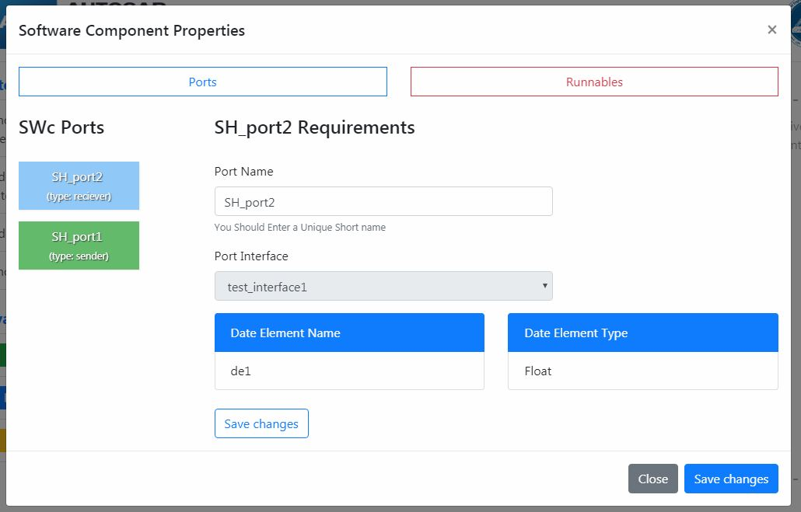  
  
  
  
  
  
  
  
also you can add new runnables from runnables tab  
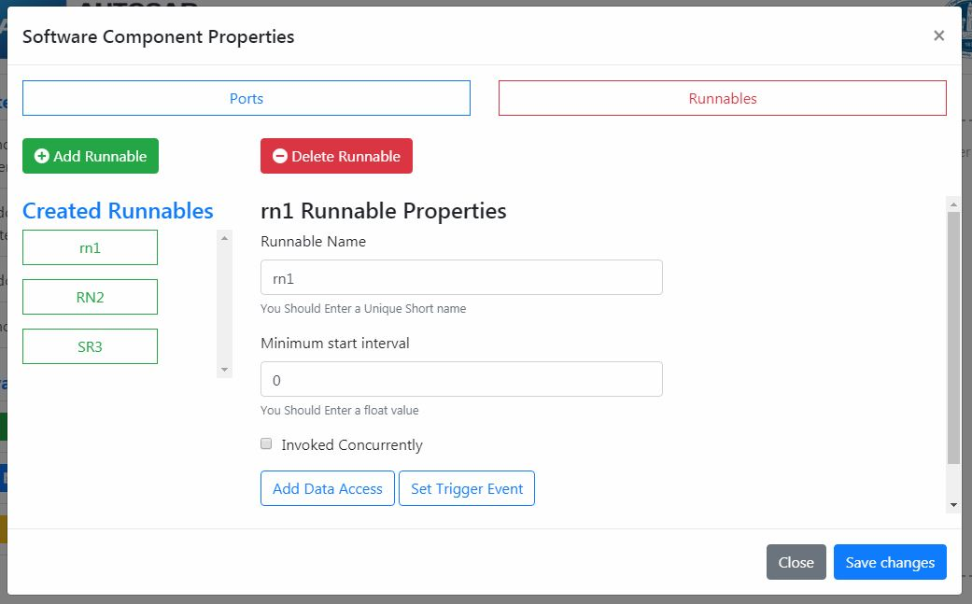  
  
At the end you can generate all SWC files and datatype with interfaces   
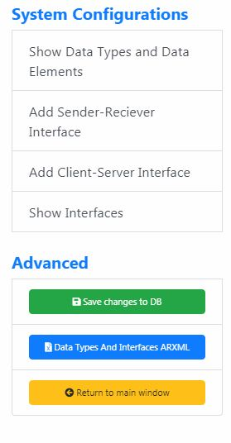

**Examples**

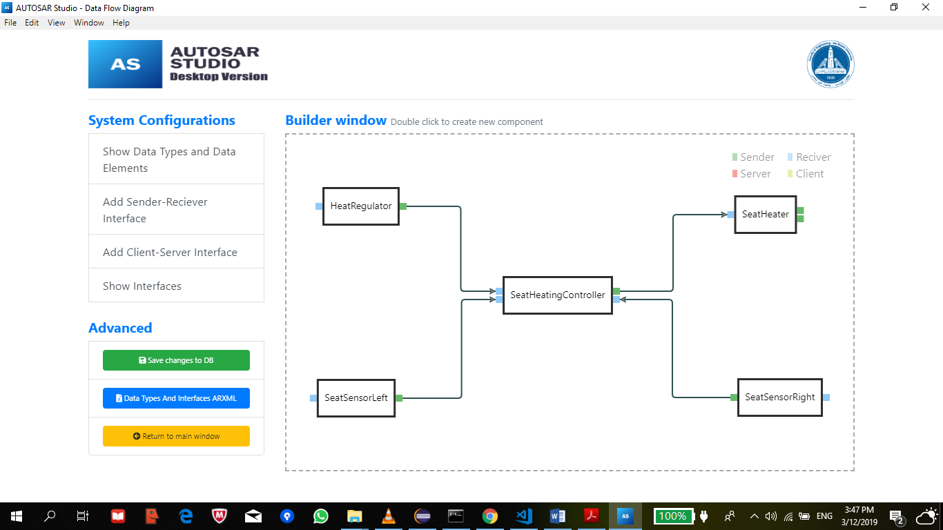seat heater example

|  |  |
| --- | --- |
| SWC | HeatRegulator |
| Port Name | Position |
| Port Type | P-Port (Sender) |
| Port Position | Right |
| Port Interface | RegulatorPosition |
| Data Element Name | Position |
| Data Element Type | UnsignedInteger_32 |

|  |  |
| --- | --- |
| SWC | HeatRegulator |
| Port Name | RegulatorIO |
| Port Type | R-Port (Receiver) |
| Port Position | Left |
| Port Interface | RegulatorIOInterface |
| Data Element Name | RegulatorValue |
| Data Element Type | UnsignedInteger_32 |

|  |  |
| --- | --- |
| SWC | SeatHeaterLeft |
| Port Name | StatusLeft |
| Port Type | P-Port (Sender) |
| Port Position | Right |
| Port Interface | LeftSeatStatusInterface |
| Data Element Name | PassengerOnLeftSeat |
| Data Element Type | Boolean |

|  |  |
| --- | --- |
| SWC | SeatHeaterLeft |
| Port Name | SensorLeftIO |
| Port Type | R-Port (Receiver) |
| Port Position | Left |
| Port Interface | LeftSensorIOInterface |
| Data Element Name | LeftSensorValue |
| Data Element Type | Boolean |

|  |  |
| --- | --- |
| SWC | SeatHeater |
| Port Name | RightSeaterIO |
| Port Type | P-Port (Sender) |
| Port Position | Right |
| Port Interface | RightSeatHeaterIOInterface |
| Data Element Name | RightHeaterValue |
| Data Element Type | UnsignedInteger_32 |

|  |  |
| --- | --- |
| SWC | SeatHeater |
| Port Name | LeftSeaterIO |
| Port Type | P-Port (Sender) |
| Port Position | Right |
| Port Interface | LeftSeatHeaterIOInterface |
| Data Element Name | LeftHeaterValue |
| Data Element Type | UnsignedInteger_32 |

|  |  |
| --- | --- |
| SWC | SeatHeater |
| Port Name | Levels |
| Port Type | R-Port (Receiver) |
| Port Position | Left |
| Port Interface | HeaterLevel |
| Data Element Name | LeftHeaterLevel |
| Data Element Name | RightHeaterLevel |
| Data Element Type | UnsignedInteger_32 |

|  |  |
| --- | --- |
| SWC | SeatSensorRight |
| Port Name | StatusRight |
| Port Type | P-Port (Sender) |
| Port Position | Left |
| Port Interface | RightSeatStatusInterface |
| Data Element Name | PassengerOnRightSeat |
| Data Element Type | Boolean |

|  |  |
| --- | --- |
| SWC | SeatSensorRight |
| Port Name | StatusRightIO |
| Port Type | R-Port (Receiver) |
| Port Position | Right |
| Port Interface | RightSensorIOInterface |
| Data Element Name | RightSensorValue |
| Data Element Type | Boolean |

|  |  |
| --- | --- |
| SWC | SeatHeatingController |
| Port Name | RightSeatStatus |
| Port Type | R-Port (Receiver) |
| Port Position | Right |
| Port Interface | RightSeatStatusInterface |
| Data Element Name | PassengerOnRightSeat |
| Data Element Type | Boolean |

|  |  |
| --- | --- |
| SWC | SeatHeatingController |
| Port Name | LeftSeatStatus |
| Port Type | R-Port (Receiver) |
| Port Position | Left |
| Port Interface | LeftSeatStatusInterface |
| Data Element Name | PassengerOnLeftSeat |
| Data Element Type | Boolean |

|  |  |
| --- | --- |
| SWC | SeatHeatingController |
| Port Name | RegulatorPosition |
| Port Type | R-Port (Receiver) |
| Port Position | Left |
| Port Interface | RegulatorPosition |
| Data Element Name | Position |
| Data Element Type | UnsignedInteger_32 |

|  |  |
| --- | --- |
| SWC | SeatHeatingController |
| Port Name | HeaterLevels |
| Port Type | P-Port (Sender) |
| Port Position | Right |
| Port Interface | HeaterLevel |
| Data Element Name | LeftHeatLevevl |
| Data Element Name | RightHeatLevevl |
| Data Element Type | UnsignedInteger_32 |